
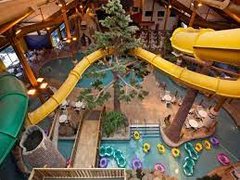
As a wealthy and retired real estate agent, I want to use my wealth to take my family of 10 on an all expenses paid vacation.

(Me at the computer sipping my coffee) I would like an indoor waterpark to be included where we stay for my grandchildren

I just graduated college and my friends and I want to take a celebratory vacation to somewhere with low costs but quality living space.



Me and my friends (who will be traveling with me) Example of a cheap but cozy hotel room for all of us to use

